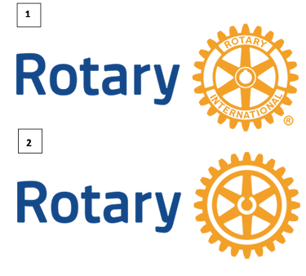
Masterbrand Signature
Masterbrand Signature (1), Masterbrand Signature simplified (2)The top version is the official logo of Rotary International. It combines the wheel with the word “Rotary” to the left for visibility and recognition. The Masterbrand Signature cannot be altered in any way.
We recommend using the simplified version, #2 if the logo will be smaller than 1.25 cm (0.5 inches) or will be embroidered or screen printed.

Rotary Club of Kalamazoo Logo
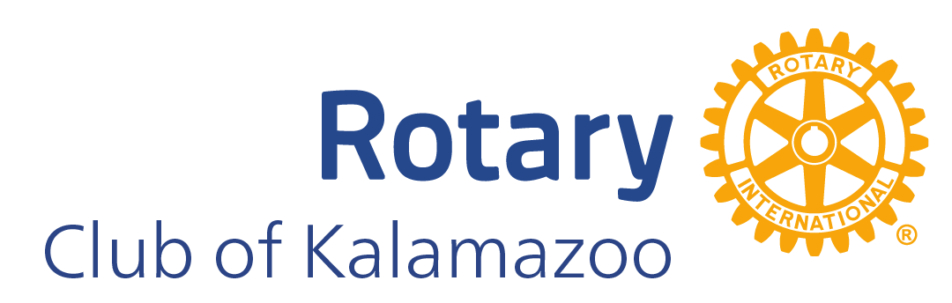
We use the name on our charter or the name our club is known by in your community in the club logo. Because the word “Rotary” is already in the logo, you don’t need to repeat it. For example, the Rotary Club of Kalamazoo, Michigan, USA, would add only “Club of Kalamazoo” below the Masterbrand Signature. The club logo was created using the tool in the Rotary Brand Center.
The club name always appears on the same side as the word Rotary. It should align on the right with the “y” in Rotary. The position and the size relationship between the word Rotary and the wheel can’t be altered.

Sponsored Clubs
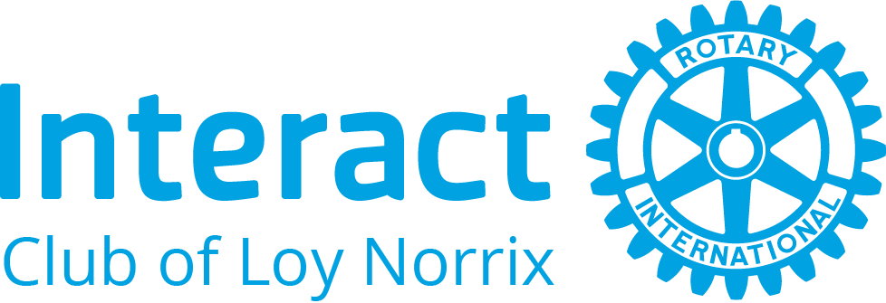
We use the correct logos also for sponsored Interact Clubs. As with the Masterbrand Signature simplified, the Interact logo is available for embroidery or screen printing (not shown).
*Sample for illustration purposes, Loy Norrix is no longer a sponsored Interact Club

